Congo, Rep.

## GNI per capita and development level

The data set shows the GNI per capita and development level of the country each year.

## # A tibble: 19 x 5  
## country iso3c date GNIperCapita devCategory   
## <chr> <chr> <dbl> <dbl> <chr>   
## 1 Congo, Rep. COG 1996 1971. Lower Middle Income  
## 2 Congo, Rep. COG 1998 2346. Lower Middle Income  
## 3 Congo, Rep. COG 2000 1836. Lower Middle Income  
## 4 Congo, Rep. COG 2002 2030. Lower Middle Income  
## 5 Congo, Rep. COG 2003 1969. Lower Middle Income  
## 6 Congo, Rep. COG 2004 1880. Lower Middle Income  
## 7 Congo, Rep. COG 2005 2131. Lower Middle Income  
## 8 Congo, Rep. COG 2006 2295. Lower Middle Income  
## 9 Congo, Rep. COG 2007 2241. Lower Middle Income  
## 10 Congo, Rep. COG 2008 2344. Lower Middle Income  
## 11 Congo, Rep. COG 2009 2739. Lower Middle Income  
## 12 Congo, Rep. COG 2010 2860. Lower Middle Income  
## 13 Congo, Rep. COG 2011 2762. Lower Middle Income  
## 14 Congo, Rep. COG 2012 3118. Lower Middle Income  
## 15 Congo, Rep. COG 2013 3132. Lower Middle Income  
## 16 Congo, Rep. COG 2014 3373. Lower Middle Income  
## 17 Congo, Rep. COG 2015 3122. Lower Middle Income  
## 18 Congo, Rep. COG 2016 2664. Lower Middle Income  
## 19 Congo, Rep. COG 2017 2475. Lower Middle Income

## GDP growth and economic growth classification

The data set shows the GDP growth and the ecomic growth classification of the country each year.

## # A tibble: 19 x 5  
## country iso3c date GDPannualGrowthRate GDPgrowthCategory4  
## <chr> <chr> <dbl> <dbl> <fct>   
## 1 Congo, Rep. COG 1996 4.29 moderate growth   
## 2 Congo, Rep. COG 1998 3.74 moderate growth   
## 3 Congo, Rep. COG 2000 7.58 fast growth   
## 4 Congo, Rep. COG 2002 4.58 moderate growth   
## 5 Congo, Rep. COG 2003 0.813 slow growth   
## 6 Congo, Rep. COG 2004 3.48 moderate growth   
## 7 Congo, Rep. COG 2005 7.76 fast growth   
## 8 Congo, Rep. COG 2006 7.99 fast growth   
## 9 Congo, Rep. COG 2007 -6.61 negative grwoth   
## 10 Congo, Rep. COG 2008 6.31 fast growth   
## 11 Congo, Rep. COG 2009 11.6 fast growth   
## 12 Congo, Rep. COG 2010 9.93 fast growth   
## 13 Congo, Rep. COG 2011 2.21 slow growth   
## 14 Congo, Rep. COG 2012 9.95 fast growth   
## 15 Congo, Rep. COG 2013 -0.712 negative grwoth   
## 16 Congo, Rep. COG 2014 5.96 fast growth   
## 17 Congo, Rep. COG 2015 -3.24 negative grwoth   
## 18 Congo, Rep. COG 2016 -10.2 negative grwoth   
## 19 Congo, Rep. COG 2017 -4.63 negative grwoth

## Development trend

The plot shows the development trend of the country.

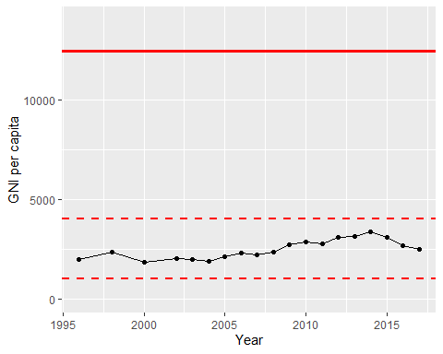

GNI Per Capita Trend